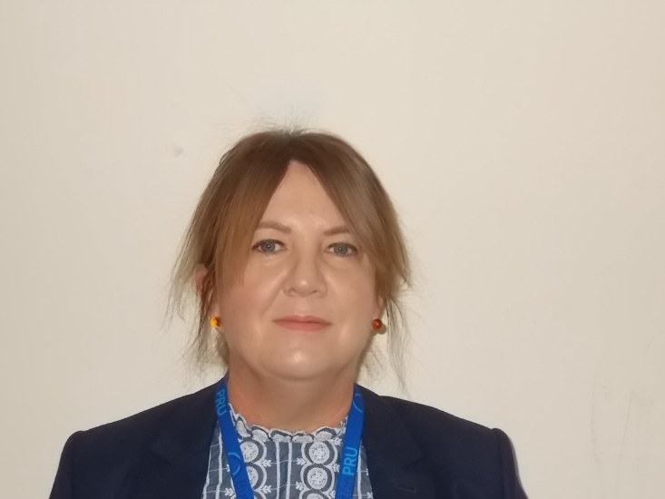
NAME: Janette Marie Bissell

TYPE OF GOVERNOR:
Elected Staff Governor
TERM OF OFFICE: From 2.11.20

ATTENDANCE RECORD: Termly Meetings:
2020-2021: 100%
SPECIFIC ROLES & RESPONSIBILITIES: Pupil Premium; Pupil Premium Plus; LAC education
SUB COMMITTEE: Teaching & Learning sub-committee; Full committee
DECLARATIONS OF BUSINESS INTERESTS: Staffordshire County Council – BPRU staff
WHY I HAVE CHOOSEN TO BE A GOVERNOR OF THE EAST STAFFORDSHIRE & TAMWORTH PRUs FEDERATION:
I wanted to become a governor at Burton PRU because I am passionate about all aspects of education. I returned to Staffordshire in 1996 after serving in Her Majesty’s Armed Forces for over ten years. I am married to a retired fire fighter and have two step-children. I have worked in education since 2002, working at a variety of secondary schools in Staffordshire, Stoke on Trent and Cheshire.
I completed my MA (part-time) at Keele University looking at the role of educational management and leadership. My various teaching roles have involved working with parents, governors, social services, police, pupils and outside agencies, helping to support them and their families in making the right life choices and decisions. Having been a governor in a previous school, I welcome the opportunity to work with the PRU to ensure pupils are encouraged to fulfil their full potential and are able to study in a safe and supportive environment.
We are a very happy and cohesive team of governors, who work together to provide the best for our schools and it’s pupils. We are supported well by our senior leadership team. As a group we ensure we keep up to date with governor training too.
I am passionate about education and giving children a good start in life, ensuring they become happy and well-rounded members of our community. I will strive to ensure we offer the best education for all our pupils and their families, to contribute to their continuing development and to help shape the future of our school.

