NAME: Mrs J Gentles
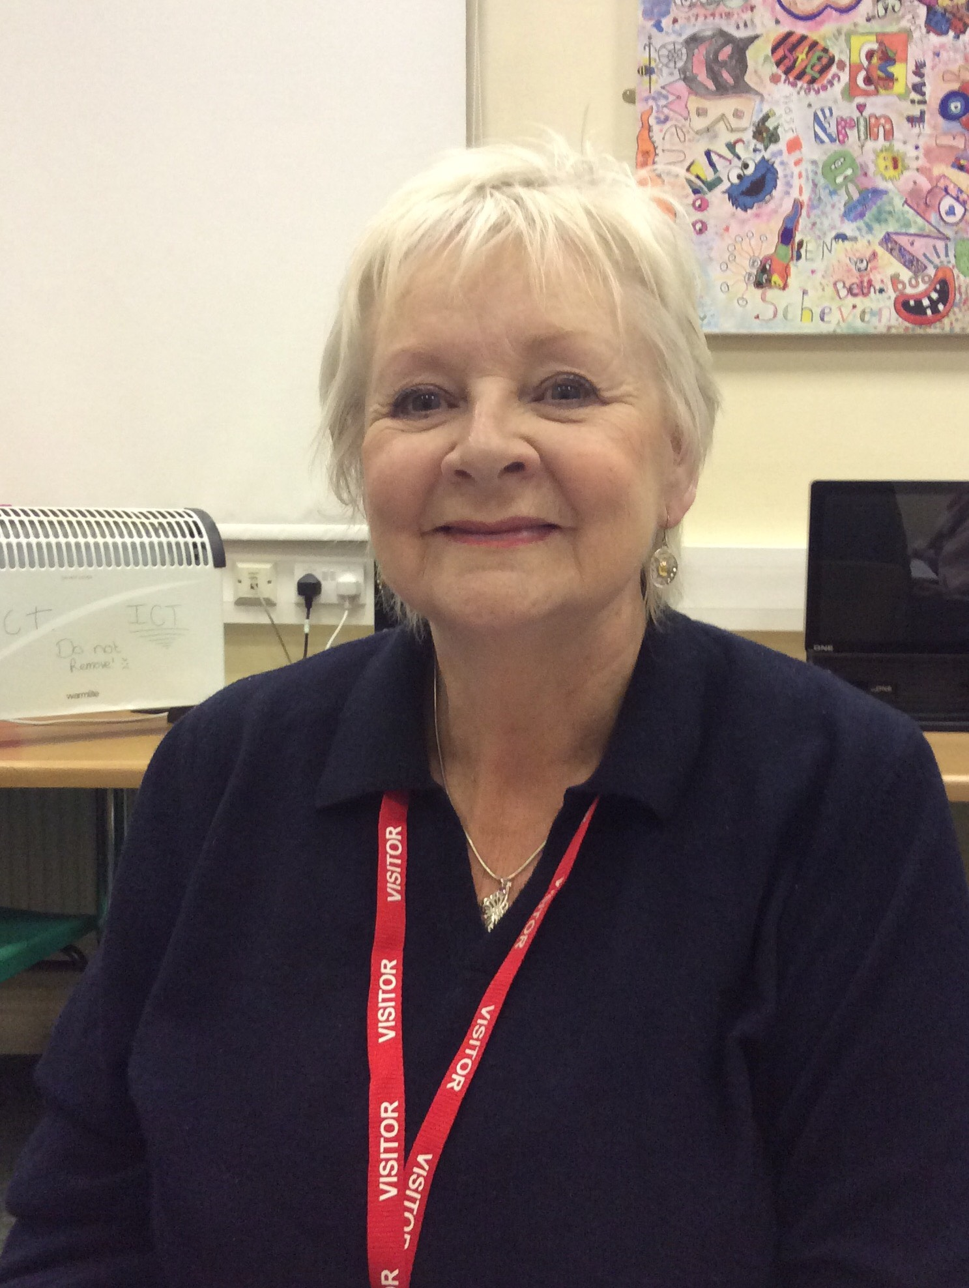
TYPE OF GOVERNOR: COMMUNITY
TERM OF OFFICE: Re-Elected from June 2016
[Federation from 1.4.18]

ATTENDANCE RECORD: Termly Meetings:
2020-2021: 100%

SPECIFIC ROLES & RESPONSIBILITIES: SEND; Staff Well-being;
SUB COMMITTEE: Full Committee / Teaching and Learning
DECLARATIONS OF BUSINESS INTERESTS: none
WHY I HAVE DECIDED TO BE A GOVERNOR OF THE EAST STAFFORDSHIRE & TAMWORTH PRUs FEDERATION:
I am a retired teacher who has worked in education for nearly fifty years. I have worked in both primary and secondary spheres as Head of music, and in later years as Head of Special Needs (Senco) at Rawlett School.

My early teaching years were spent on Tyneside and when I married I moved to the Midlands. After our three children came along I retrained in Special Needs. I worked with SENSS (Special Educational Needs Support ) as both tutor and advisory teacher. During this time I gained a post graduate diploma in assessment and teaching for Dyslexia. This still enables me to provide assessment for access arrangements for examinations at Kettlebrook.

I have always been passionate about education particularly with students who are vulnerable. I feel I have a wealth of experience in this field with which I could help and support Kettlebrook & Burton PRUs.

It is a privilege to work with the staff and students .The degree of commitment and quality of
teaching are unsurpassed in my experience. My aim is to continue to work with, challenge and support Kettlebrook & Burton PRUs to grow and develop further to become the hub of Alternative provision in Tamworth & Burton and become amazing schools for our young people to achieve their very best.

