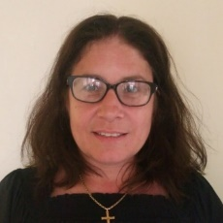 Miss K Wright Careers Adviser BSc (Hons), Dip RSA, RCDP
I have been a level 6 Careers Adviser for 20 years working within different schools and alternative provision settings in the Tamworth and Burton area. I have worked across various mainstream schools, community-based venues, pupil referral units, training providers, with students who are electively home educated and those who are NEET (Not in Employment, Education or Training). I have significant experience of working with young people with complex needs and barriers to progression. I enjoy supporting young people to develop their ideas and start sowing the seeds of their early career. I believe that the process of guidance is not just about what information young people need to make key decisions, but also about the processes involved in decision making. These decision-making skills help ensure our young people are equipped with some of the tools they will continue to need to build their careers throughout life.
I am a qualified and registered professional member of the Careers Development Institute (CDI)

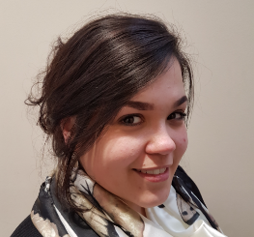 Ms K Sultan Careers Leader, NVQ in childcare
I have been working with a variety of range of students for around 5 years. At Kettlebrook Short Stay School, I have built up great relationships with our young people and this has been used to further support them with their POST 16 placements. As the careers leader, I am responsible for keeping a permeant communication stream between the career’s adviser and the young people, during the days which the careers adviser is off site. I am responsible for providing our young people with college information within their area as and when this arises; as well as helping our young people to discover what they want to do with their futures; work with students when they return to school from Work Experience etc. I believe that our young people do need guidance in order to achieve their full potential and I am honoured to be part of this journey.

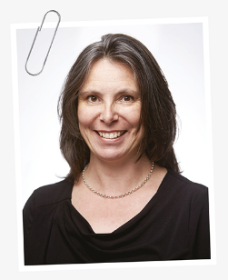 Mrs K Rogers Executive Headteacher
I have been the Headteacher at KSSS for over 10 years, during this time 89% of our Yr 11 students have progressed onto their chosen POST 16 destination – I want all my students to achieve their chosen start to their careers. Over the last 8 years, one Yr 11 student has been able to secure an apprenticeship from their Work Experience (that they have undertaken at KSSS). The team of staff at KSSS, parents/carers & other agencies work hard to enable each student to achieve the success that they deserve. We also have a team of companies and their staff who offer their time, expertise and support our commitment to quality Information Advice & Guidance for all our students.
KSSS has a special working relationship with Euro Car Parts – who will be interviewing all KS 4 students to give them interview experience for PSOT 16 destinations of College or the work place; they offer curriculum and careers information and support – its great to have this industry support for our students. The Stoke on Trent Careers & Enterprise team of staff – support the careers team to access lots of information and opportunities for our students; Entrust Careers team link with KSSS to continue to support our students up until 18; they have also enabled KSSS to achieve recognition for our work in careers. Thank you to you all.

