Careers Programme & Provider Access Policy
Introduction

This policy statement sets out the school’s arrangements for managing the access of providers to pupils at the school for the purpose of giving them information about the provider’s education or training offer. This complies with the school’s legal obligations under Section 42B of the Education Act 1997. As well as the careers overview programme that is accessible for all students at Kettlebrook Short Stay School (KSSS).

Careers Leaders

At KSSS we have a team of Careers staff: Kelly Wright the Level 6 Careers Advisor and member of the Careers Development Institute (CDI). Kirsty Sultan is the link between staff and students, inviting guests in etc. Sophie Norrington is the PSHE Coordinator (Careers is also taught through PSHE), Kirsty Rogers is the Headteacher with strategic responsibility. Ashley Stops is our WEX Coordinator. Denise Robertson is Management Committee Governor.

* Kelly Wright is the independent careers advisor:
  - is presented in an impartial manner, showing no bias or favouritism towards a particular institution, education or work option;
  - includes information on the range of education or training options, including apprenticeships and technical education routes;
  - is guidance that the person giving it considers will promote the best interests of the pupils to whom it is given.

Student entitlement

All students in years 7-11 are entitled: KSSS mainly has 70% KS 4 students.
- to find out about technical education qualifications and apprenticeships opportunities, as part of a careers programme which provides information on the full range of education and training options available at each transition point;
- to hear from a range of local providers about the opportunities they offer, including technical education and apprenticeships – through options events, assemblies and group discussions and taster events;
- to understand how to make applications for the full range of academic and technical courses.
- In Yr 11 – all students have 1:1 IAG throughout Year 11 from Sept to July. Staff also support applications into FE and employment in August and Sept.

Management of provider access requests
Procedure
A provider wishing to request access should contact Mrs K Rogers, Headteacher, Telephone: 01827 312840 Email: admin@kettlebrook.staffs.sch.uk

Opportunities for access

A number of events are integrated into the school careers & PSHE programme, as well as specific events that are organised (as and when opportunities arise) to enable all students to have access to careers information. KSSS also offers providers an opportunity to come into school to speak to student and/or their parents/carers during the academic year.

KS 4 students also can have the opportunity to undertake a weekly Work Experience (WEX)Placement which sill compliment their Individual Learning Plan and their POST 16 aspirations. All H&S checks are undertaken before the placement commences, this includes the student having interviews to achieve the WEX placement.

OVERVIEW of Careers Input: All students have access to careers related activities; presentations – employers, employees, Further Education etc

 | Autumn Term | Spring Term | Summer Term
KS 3 | Careers in PSHE; Tutor time/assembly etc | Careers in PSHE; Tutor time/assembly etc | Careers in PSHE; Tutor time/assembly etc
Year 10 | NEC – Skills Show trip. Tamworth Careers Fair. | Careers in PSHE; Tutor time/assembly | 1:1 IAG session to start POST 16 planning.
Year 11 | NEC – Skills Show trip.  Careers Fairs  Careers in PSHE; Tutor time/assembly.  1:1 IAG interviews. | 1:1 IAG sessions to support applications; CV; interviews etc.  Post-16 taster sessions at different Colleges if available.  Support visits and interviews.  Industry Link Mock Interviews | Further 1:1 if needed to secure POST 16 placements.  Support on results day in August.
POST 16 | IAG tracking of current and previous cohorts during the Autumn term.

Parents/Carers are involved in their child’s careers aspirations from pre-admissions meetings on entry; at Performance Review Days during the year to final Year 11 IAG & POST 16 placements.

Premises and facilities
KSSS will make the main hall, classrooms or private meeting rooms available for discussions between the provider and students, as appropriate to the activity. The school will also make available AV and other specialist equipment to support provider presentations. This will all be discussed and agreed in advance of the visit with the Careers Leader or a member of their team.
Providers are welcome to leave a copy of their prospectus or other relevant course literature with PSHE.

OTHER RELATED DOCS:
KSSS WEBSITE – Curriuclum - Careers
GATSBY Benchmark – progress
Careers Policy
Meet the Careers Team
Weblinks for student, parents/carers
Mock Interviews from Industry Links
Careers Programme; Yr 10 & Yr 11 Student booklets, Yr 11 Careers Action Plans and Reviews

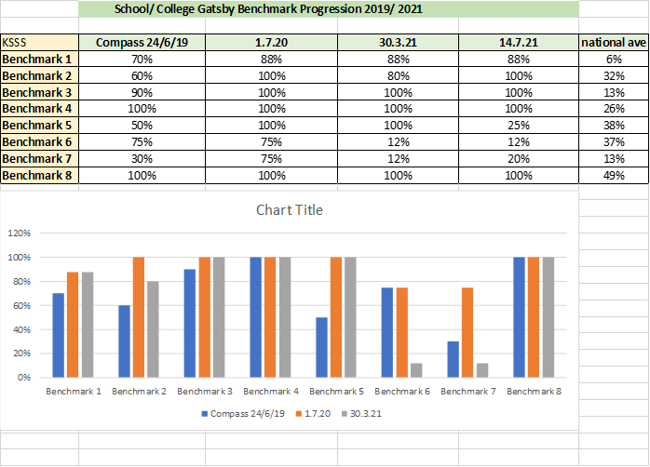

Further information

Useful resources and external organisations
- Gatsby Good Career Guidance. A report on improving career guidance in secondary schools which includes the Gatsby Benchmarks.
- Gatsby Good Practice. A website which shares good practice from the North East pilot of the Gatsby Benchmarks, and other information and support for schools.
- Compass. A self-evaluation tool to help schools to evaluate their careers and enterprise provision and benchmark against the Gatsby Benchmarks and compare it with other schools.
- State of the Nation 2017. A report on the careers and enterprise provision in secondary schools in England in 2016/17. It examines how schools are performing in relation to the Gatsby Benchmarks, based on data from responses to the Compass tool.
- Careers & Enterprise Company. The Careers & Enterprise Company brokers links between employers, schools and colleges in order to ensure that young people aged 12-18 get the inspiration and guidance they need for success in working life.
- Careers & Enterprise Company: Schools and Colleges. Connects schools to businesses volunteers and careers activity programmes.
- National Careers Service. The National Careers Service provides information, advice and guidance to help people make decisions on learning, training and work opportunities. The service offers confidential and impartial advice. This is supported by qualified careers advisers.
- Amazing Apprenticeships. A website to make it easy for teachers and careers advisers to access the latest information about apprenticeships.
- Apprenticeships Support and Knowledge for Schools (ASK). A network of teachers, careers advisers and ambassadors who will promote apprenticeships and traineeships in positive ways to year 10-13 pupils in the North, Midlands, London and the South.
- Baker Dearing Educational Trust. Information on University Technical Colleges.
- Career Development Institute. The Career Development Institute is the single UKwide professional body for everyone working in the fields of careers education, career information, advice and guidance, career coaching, career consultancy and career management. It offers affiliate and individual membership to schools which includes free CPD webinars, regular digital newsletters, a quarterly magazine, online networking groups and training at a preferential rate.
- Career Development Institute Framework for careers, employability and enterprise education. A framework of learning outcomes to support the planning, delivery and evaluation of careers, employability and enterprise education for children and young people.
- UK Register of Career Development Professionals. The single national point of reference for ensuring and promoting the professional status of career practitioners.
- Quality in Careers Standard. The Quality in Careers Standard in the national quality award for careers education, information, advice and guidance.
- Find an Apprenticeship. Search and apply for an apprenticeship in England.
- LMI for All. An online data portal, which connects and standardises existing sources of high quality, reliable labour market information (LMI) with the aim of informing careers decisions. This data is made freely available via an Application Programming Interface (API) for use in websites and applications.
- STEM Ambassadors. A nationwide network of over 30,000 volunteers from a wide range of employers, who engage with young people to provide stimulating and inspirational informal learning activities in both school and non-school settings
- Unistats. The official website for comparing UK higher education undergraduate course data. The site includes information on university and college courses, Teaching Excellence and Student Outcomes Framework (TEF) ratings, student satisfaction scores from the National Student Survey, employment outcomes and salaries after study and other key information for prospective students.
- Your Daughter’s Future. A careers toolkit for parents.
- Your Life app. Informs and inspires young people by giving them the opportunity to discover hundreds of varied career options.

Other relevant departmental advice and statutory guidance
- Governance handbook. Guidance outlining the roles and duties of school governors and academy trusts.
- Special educational needs and disability code of practice: 0 to 25 years. A statutory code which explains the duties of local authorities, health bodies, schools and colleges to provide for those with special educational needs under Part 3 of the Children and Families Act 2014.
- Participation of young people: education, employment or training. Statutory guidance for local authorities on their duties relating to the participation of young people in education, employment or training.

Other departmental resources
- Careers strategy: making the most of everyone’s skills and talents. Government’s plan for raising the quality of careers provision in England.
- Post-16 technical education reforms: T level action plan. Government’s progress on the reforms to technical education set out in ‘Post-16 skills plan’, confirms next steps and opportunities for engagement by interested parties.

