NAME: Miss D Robertson
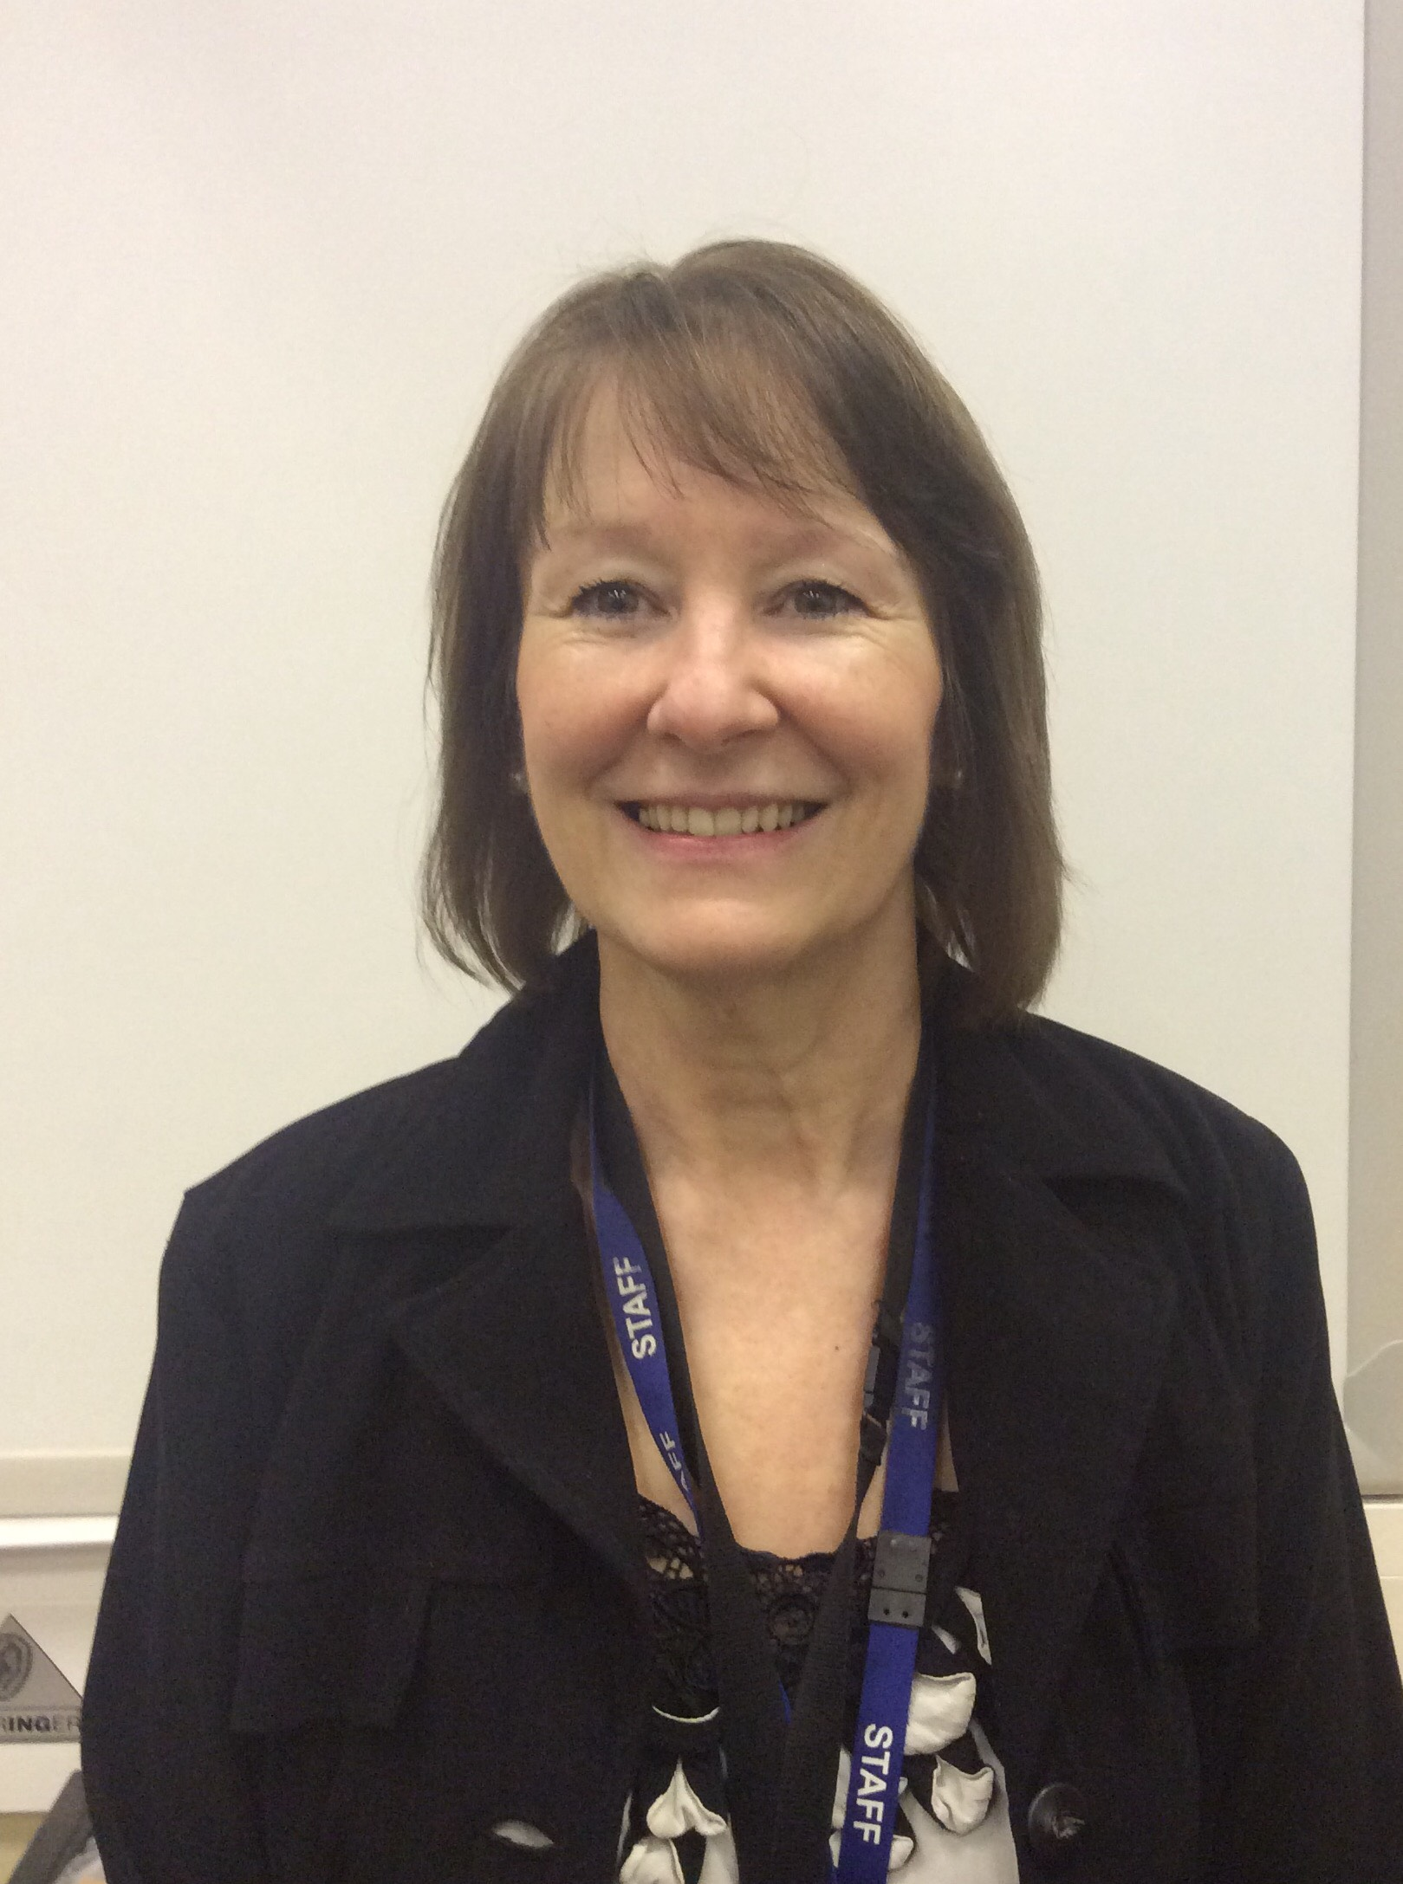
TYPE OF GOVERNOR: STAFF - KSSS
TERM OF OFFICE: From: Oct 2014
[Federation from 1.4.18]
ATTENDANCE RECORD: Termly Meetings:
2020-2021: 100%

SPECIFIC ROLES & RESPONSIBILITIES: Staff
SUB COMMITTEE: Full committee / Learning: Curriculum; Teaching and Learning
DECLARATIONS OF BUSINESS INTERESTS: None
WHY I HAVE DECIDED TO BE A GOVERNOR OF THE EAST STAFFORDSHIRE & TAMWORTH PRUs FEDERATION:
Throughout my adult life I have always worked with children; and have been totally dedicated to their well-being. This included: Leader of Toddlers at the St Chad’s Hall Sunday School and George Lane Mums/Toddlers; of my two children’s schools PTA’s; being part of the Lichfield and District Scout Movement; for which I got a Long Service Award.
I have worked in education, within Special Needs and with ‘young people who need nurturing’ for twenty-five years. I have seen many changes here as I have been at Kettlebrook for sixteen years; my role has changed, to meet the changing needs of our community in Staffordshire. Caring, Sharing and Aspiring for those around me I have found has been my vocation. I have further supported this by: my self-organising, ongoing finance and devoting time to obtain extensive qualifications; to support my service to children and Diminishing the Difference.
At present I am the Senior Learning Support Assistant, (LSA), at KSSS. I share our good practice within the leadership of the Tamworth LSA Network.
A vacancy arose to join the Management Committee and I felt it was an ideal opportunity to develop my role and address our Motto further.

